Dev Logs
Week 1
Just production – no documentation
Started some in engine work after looking at some tutorials
Got tilemap tiles to display through code
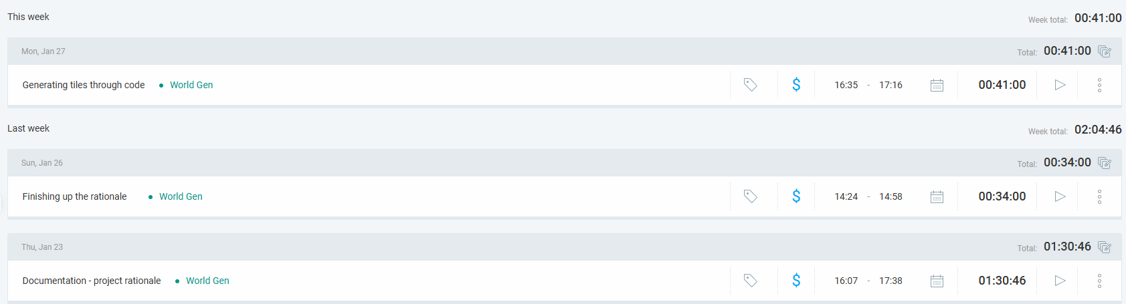
Week 2
Product design
Back-end gen system generating grid positions and storing them in an array
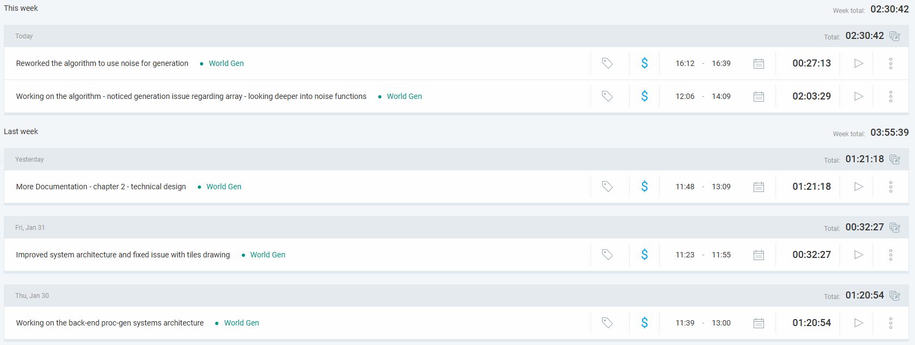

Week 3
Project Plan
Finishing up AE1
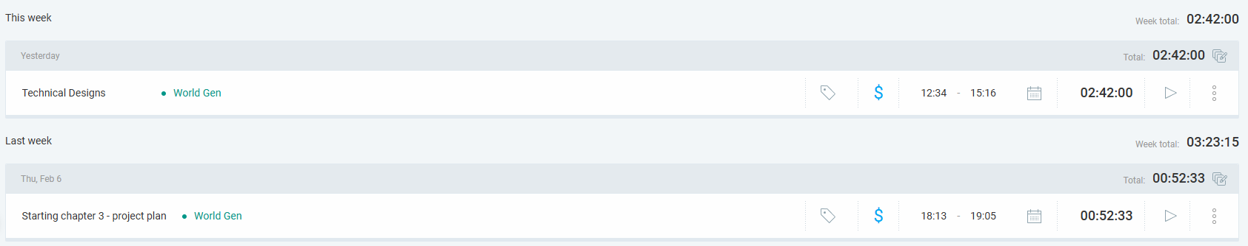
Week 4
Production
Added underground generation
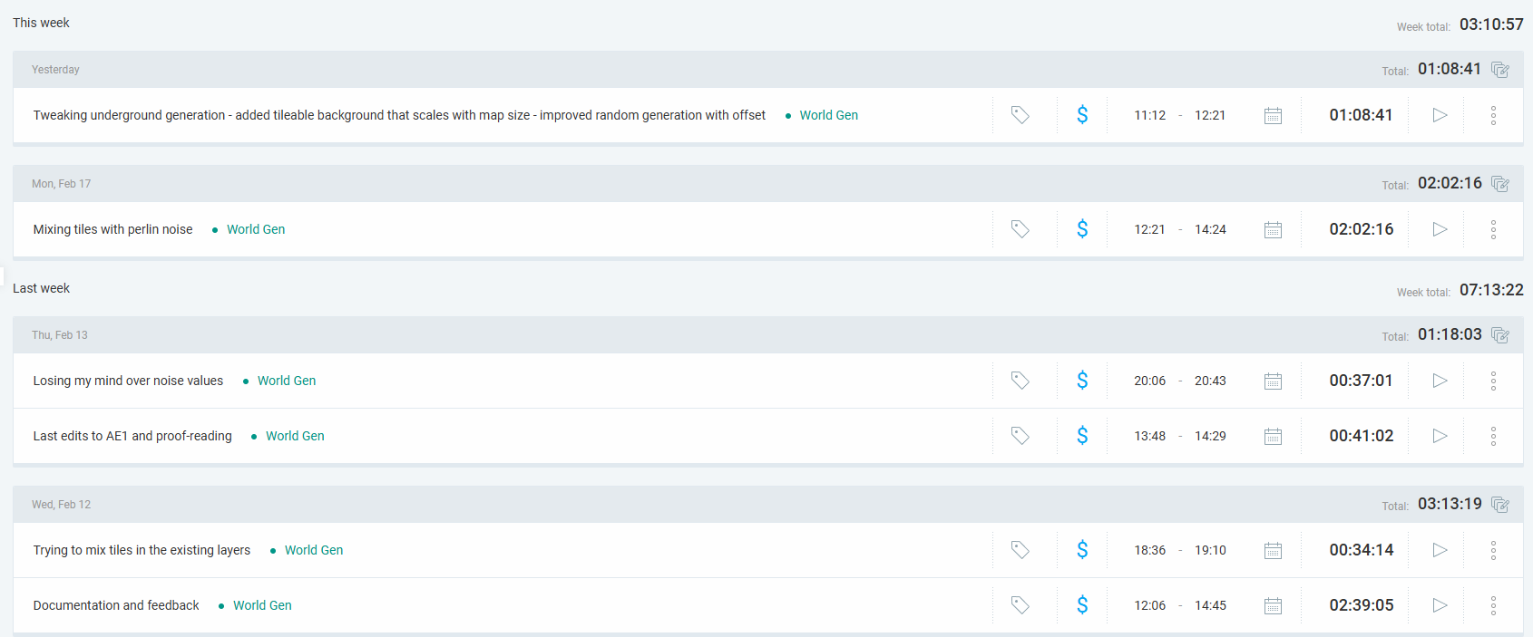
Week 5
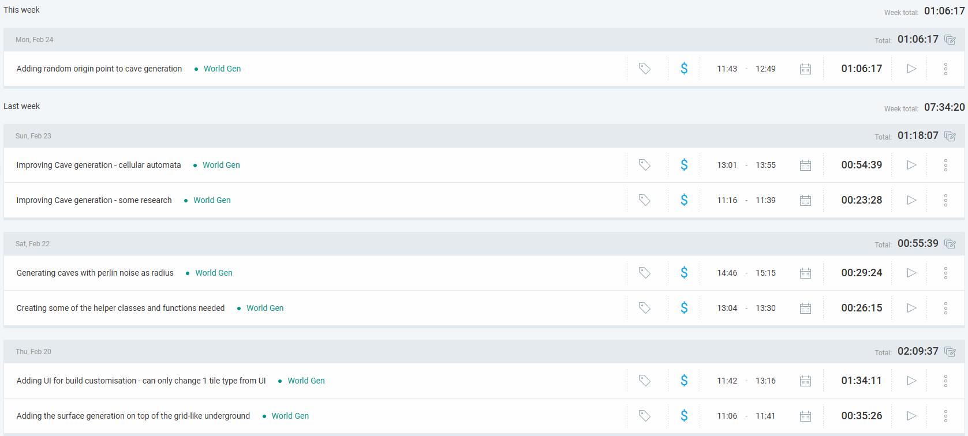
Week 6
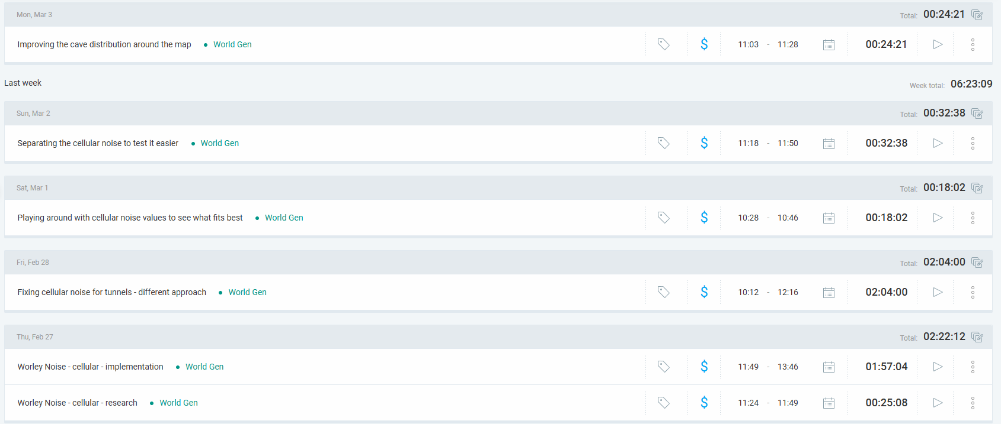
Week 7
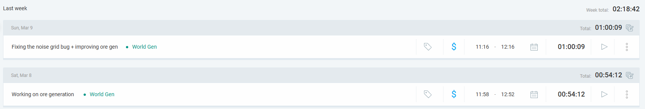
+ Dan feedback session call where he suggested different solutions which led to flood fill and branching algorithms
Week 8
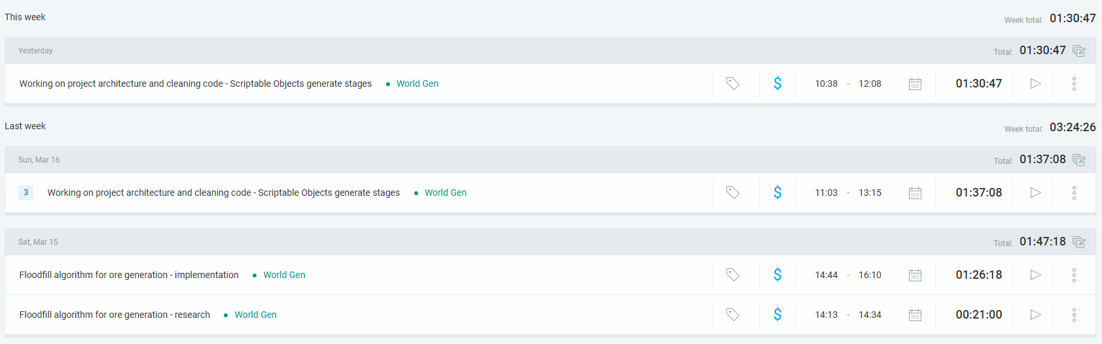
Week 9
Testing plan
Preparation for testing
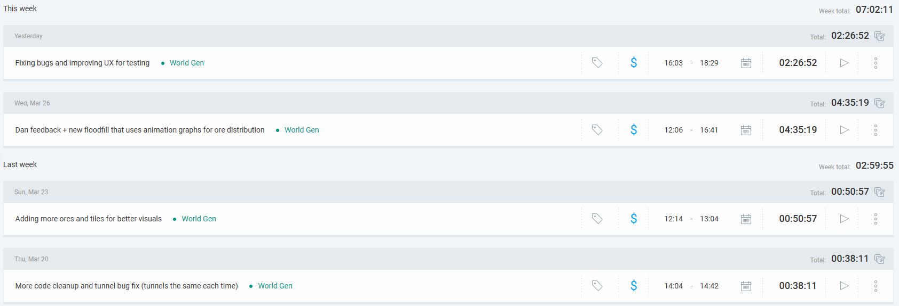

Testing
Bug Tracking – Excel file
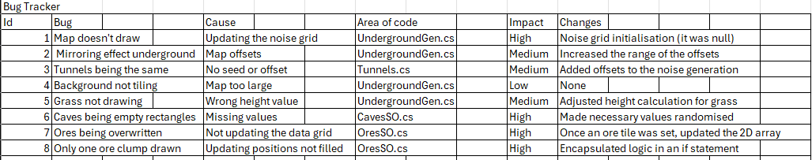
Internal Testing
Considering that I am making a tool and not a game, I do not have all that much ‘user interaction’ that I can test. The few elements I did test are as follows:
Build version –
- Tested that the player can erase and generate worlds at runtime
- Tested that the player can look around with the WASD keys and zoom in/out to inspect the world
In-Engine version –
- Tested that the changes made in inspector are reflected in the world generation
- Made the inspector as clean and compact as possible, while allowing customization, to make it easier for the user

Beta Test & Heuristic Design
For my testing, having such a simplistic product, I will only be using survey forms. One to get an idea of the tester’s knowledge and experience prior to the test and one post-test survey for feedback.
This is important for my project because I am planning to create a tool rather than a game, so my testers would need to be developers rather than an average consumer. However, the tool is meant to create environments for a game, so it would not hurt to get some non-developer feedback too. To this end, I plan to have the average consumer test a build version and the developers test the in-engine version. My questions will also be designed in a way to cater to both types of testers as much as possible.

Testing Sample
Target – 20

Feedback Analysis

Adaptation to feedback

Ore Biome idea
After looking at cellular noise, try making an ore biome that follows that principle
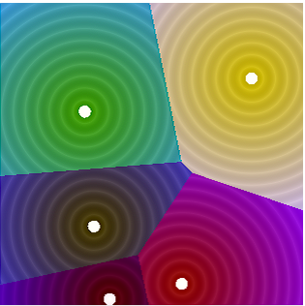
Each colour would be a different ore and the border between them would just be rock

